# **Testing of Purchasing Power parity theory(PPP): Impact of relative prices on spot exchange rate over 60 years on different countries.**

**Project by School of Economics (PG Batch of 2022-24) :**

* Spandan Ganguli (ME22006)
* Anumoy Modak (ME22002)
* Bhaskar Das (ME22003)
* Abhishek Kumar (ME22001)
* Sichitaj Sahoo (ME22007)

**Project Guide: Dr Golaka C. Nath**

**Paper:** International Economics and Exchange rate Trading and Forecasting (IETF)

**Abstract**

We empirically test if Purchasing Power Parity theory (PPP) holds in the case of United Kingdom(GBP), Japan(JPY), Switzerland(CHE), Thailand(THB), India(INR) and Germany(EUR), using USD as the basis currency and United State CPI as the base Price basket. Specifically, we test if the relative prices between USA and the chosen country effects the percentage change in Spot Rate between USA and the chosen country. We find that the theory only holds for Spot exchange rate of Germany(USD/EUR) i.e., for Germany percentage change in Spot exchange rate (USD/EUR) is a function of the relative price difference between USA and Germany. For all other countries, relative prices cannot explain the change in Spot exchange rate (USD/Chosen Country currency).

## **Contents**

1. Introduction
2. Research Methodology
3. Research Findings
4. Conclusion
5. Descriptive Statistics\Graph
6. Bibliography

## **Introduction**

The Purchasing Power Parity (PPP) principle states the idea that the exchange rates are determined by the amount of different other currencies that are required to purchase a representative bundle of goods while the Consumer Price Index (CPI) measures the overall change in consumer prices based on a representative basket of goods and services over time and the Exchange Rate (ER) of a currency is the value of one currency against another currency. Ex: The value of USD against INR. There are two types exchange rates, i.e., fixed and flexible.

The significance of the PPP theory is that it is used by macroeconomists to compare the values of different currencies through the ‘basket of goods’ approach. The main significance of PPP theory is to create a bridge of relationship between the Spot Exchange rate and the relative price of a respective country.

There are two forms of PPP theory.

1. Absolute or static form

2. Relative or dynamic form

The absolute form of PPP theory is stated in terms of levels of price and exchange rates, rather than in terms of inflation and changes in exchange rates while the relative form of PPP theory is stated in terms of inflation and changes in exchange rates.

## **Methodology**

**Absolute Purchasing Power Parity model statement:**

$Spot\left(\$/{LCU}\right)=α+ β\left(\frac{Pus}{Plc}\right)+ e$

Where,

**LCU** = Local Currency Unit (EUR, GBP, THB, INR, CHE, JPY)

***Pus*** = Price Basket (CPI) in United States of America

***Plc*** = Price Basket (CPI) in Local Country (*Pind, Pger, Puk, Pjap, Pswiss, Pthai)*

**α** =Intercept

**β** = Coefficient of relative price

***e*** = Error term

Here, (Pus/Plc) gives us the Ratio between prices of the commodity baskets in different countries. For this research we have chosen yearly CPI to serve as the price basket of commodities. This regression will yield results. However, while the Spot Exchange rates of the chosen countries are stationary, some of the Price basket(CPI) of the chosen countries show trends that make any regression run on them spurious. We must thus abandon the Absolute Purchasing Power Parity Model in exchange for a model where all chosen country Price Baskets( CPI) are stationary). This can be achieved simply by using the Dynamic Purchasing Power Parity model, as this model uses Lag Differentiated values to estimate change in Spot and price Baskets

**Dynamic Purchasing Power Parity model statement:**

$$\dot{Spot}\left(\$/{LCU}\right)=α+ β\left(\frac{\dot{Pus}-\dot{Plc}}{1+\dot{Plc}}\right)+ e$$

Where,

$\dot{Spot}\left(\$/{LCU}\right)$ = **(***Spot($/LCU) t-1* ***-*** *Spot($/LCU) t***)****/***Spot($/LCU) t* i.e. Percentage change in Spot Rate.

$\dot{Pi}$ = Price Basket (CPI) of country i (at time t – 1)  - Price Basket (CPI) of country i (at time t) / Price Basket (CPI) of country i (at time t)

i.e. Percentage change in Price Basket (CPI)

$\left(\frac{\dot{Pus}-\dot{Plc}}{1+\dot{Plc}}\right)=$ Relative change in between Price baskets of United States and Local Country

**α** = Intercept

**β** = Coefficient of relative price

***e*** = Error term

We can now test Purchasing Power Parity theory. All Econometrics attached alongside paper.

## **Research Findings**

|  |  |
| --- | --- |
| **Dependent** | **Coeff. of relative changes in Price Basket** |
| % change in Spot(USD/EUR) | 2.809008**  (1.211774) |
| % change in Spot(USD/GBP) | 0.1951886  (0.4397803) |
| % change in Spot(USD/INR) | 0.0758663  (0.1441766) |
| % change in Spot(USD/JPY) | 0.8689077  (0.5693011) |
| % change in Spot(USD/CHE) | 1.68739**  (0.802899) |
| % change in Spot(USD/THB) | 0.1664551  (0.1939972) |
| H0: Coeff. of relative changes in Price Basket = 0  Level of Significance(alpha): 1%=* 5% =** 10%=*** | |

OF all regressions run, the Coeff. Of relative prices is significant only for Spot(USD/EUR) and Spot(USD/CHE). For all other Spot rates, the null hypothesis cannot be rejected, and thus, Purchasing Power parity does not hold.

Where the null hypothesis is rejected, the coefficients of the Independent **are more than 1 and positive**, indicating that **Positive relative changes in price baskets** will **depreciate USD**. This is in line with the statement of the theory: The increase in prices in the United States or decrease in prices in other countries will lead to decrease in demand for US goods, and thus decrease in demand for USD, causing the USD to Causing the USD to depreciate.

## **Conclusion**

We find that the Purchasing Power Parity theory does not hold for all the selected countries, which implies that Purchasing power Parity either only works for certain countries, or is not the only determinant of exchange rate. We can safely conclude that using relative prices to determine the spot rate of countries will lead to false conclusions.

A possible explanation is that difference in consumption preferences leads to differences in domestic prices, preventing the Exchange rate from being equal across countries.

An extension of this conclusion is that as the Purchasing Power Parity does not hold, trade between countries will yield supernormal profits. The Law of one price thus does not hold in Trade goods.

## **Graph and Data**

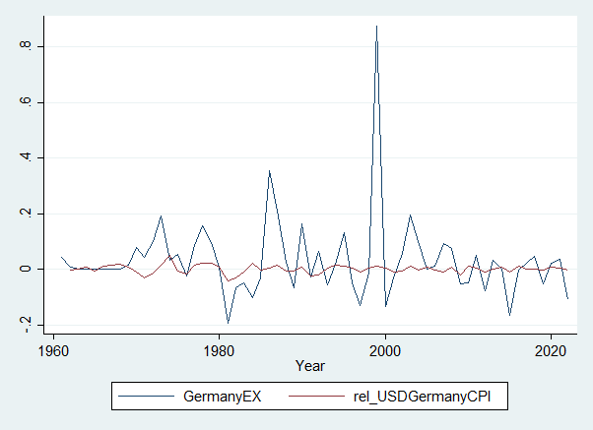

|  |  |  |  |
| --- | --- | --- | --- |
| ***GermanyEX*** |  | ***rel_USDGermanyCPI*** |  |
|  |  |  |  |
| Mean | 0.032145817 | Mean | 0.000409294 |
| Standard Error | 0.018205435 | Standard Error | 0.001903404 |
| Median | 0.008811057 | Median | 0.002452997 |
| Standard Deviation | 0.14334974 | Standard Deviation | 0.01486606 |
| Sample Variance | 0.020549148 | Sample Variance | 0.000221 |
| Kurtosis | 19.41352112 | Kurtosis | 1.690203675 |
| Skewness | 3.521540382 | Skewness | -0.103224747 |
| Range | 1.071134998 | Range | 0.090056974 |
| Minimum | -0.195722714 | Minimum | -0.040808145 |
| Maximum | 0.875412284 | Maximum | 0.049248829 |
| Sum | 1.993040678 | Sum | 0.024966943 |
| Count | 62 | Count | 61 |

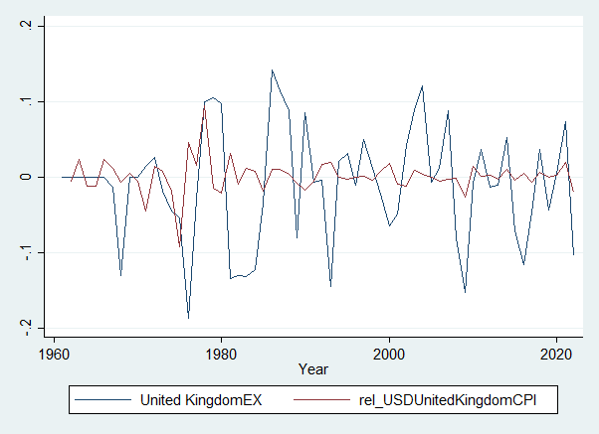

|  |  |  |  |
| --- | --- | --- | --- |
| ***UnitedKingdomEX*** |  | ***rel_USDUnitedKingdomCPI*** |  |
|  |  |  |  |
| Mean | -0.010272601 | Mean | 0.00087303 |
| Standard Error | 0.009573357 | Standard Error | 0.002875621 |
| Median | -0.002420988 | Median | 0.000166549 |
| Standard Deviation | 0.075380686 | Standard Deviation | 0.022459321 |
| Sample Variance | 0.005682248 | Sample Variance | 0.000504421 |
| Kurtosis | -0.310834383 | Kurtosis | 8.855947672 |
| Skewness | -0.230596692 | Skewness | -0.022857948 |
| Range | 0.329980087 | Range | 0.187347457 |
| Minimum | -0.187721152 | Minimum | -0.093145609 |
| Maximum | 0.142258935 | Maximum | 0.094201848 |
| Sum | -0.636901238 | Sum | 0.053254843 |
| Count | 62 | Count | 61 |

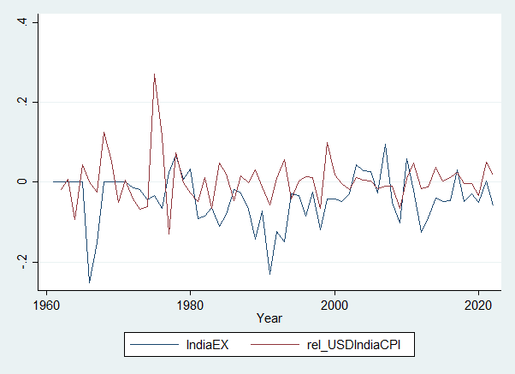

|  |  |  |  |
| --- | --- | --- | --- |
| ***IndiaEX*** |  | ***rel_USDIndiaCPI*** |  |
|  |  |  |  |
| Mean | -0.041991554 | Mean | 0.003363272 |
| Standard Error | 0.008163064 | Standard Error | 0.007448796 |
| Median | -0.032615286 | Median | 0.002210784 |
| Standard Deviation | 0.064276028 | Standard Deviation | 0.058176954 |
| Sample Variance | 0.004131408 | Sample Variance | 0.003384558 |
| Kurtosis | 1.690072513 | Kurtosis | 6.912287352 |
| Skewness | -0.879069412 | Skewness | 1.61904337 |
| Range | 0.346904913 | Range | 0.402370244 |
| Minimum | -0.251170562 | Minimum | -0.130967408 |
| Maximum | 0.095734351 | Maximum | 0.271402836 |
| Sum | -2.603476339 | Sum | 0.205159575 |
| Count | 62 | Count | 61 |

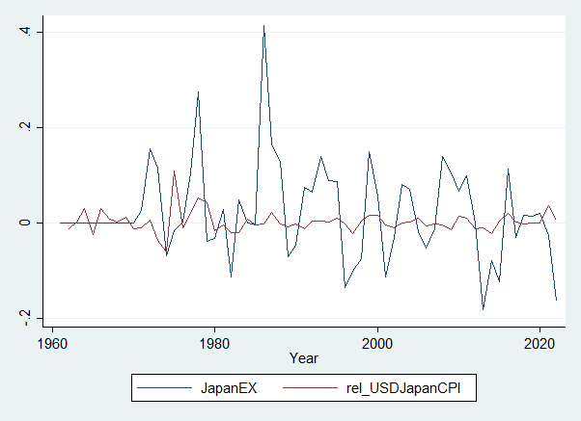

|  |  |  |  |
| --- | --- | --- | --- |
| ***JapanEX*** |  | ***rel_USDJapanCPI*** |  |
|  |  |  |  |
| Mean | 0.021069933 | Mean | 0.002067209 |
| Standard Error | 0.01281418 | Standard Error | 0.002920629 |
| Median | 0 | Median | -0.000852747 |
| Standard Deviation | 0.100898953 | Standard Deviation | 0.022810843 |
| Sample Variance | 0.010180599 | Sample Variance | 0.000520335 |
| Kurtosis | 3.064638993 | Kurtosis | 7.664553086 |
| Skewness | 1.003447457 | Skewness | 1.599696796 |
| Range | 0.597914792 | Range | 0.16858612 |
| Minimum | -0.182438473 | Minimum | -0.06035623 |
| Maximum | 0.415476319 | Maximum | 0.10822989 |
| Sum | 1.306335841 | Sum | 0.126099733 |
| Count | 62 | Count | 61 |

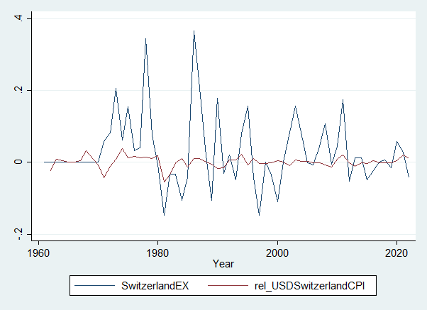

|  |  |  |  |
| --- | --- | --- | --- |
| ***SwitzerlandEX*** |  | ***rel_USDSwitzerlandCPI*** |  |
|  |  |  |  |
| Mean | 0.029115299 | Mean | 0.001053165 |
| Standard Error | 0.012386081 | Standard Error | 0.001967743 |
| Median | 0.000356826 | Median | 0.000674863 |
| Standard Deviation | 0.0975281 | Standard Deviation | 0.015368562 |
| Sample Variance | 0.00951173 | Sample Variance | 0.000236193 |
| Kurtosis | 2.801167732 | Kurtosis | 3.421778186 |
| Skewness | 1.30412745 | Skewness | -1.06028218 |
| Range | 0.514241709 | Range | 0.09371002 |
| Minimum | -0.1483502 | Minimum | -0.055454444 |
| Maximum | 0.365891509 | Maximum | 0.038255576 |
| Sum | 1.805148513 | Sum | 0.064243066 |
| Count | 62 | Count | 61 |

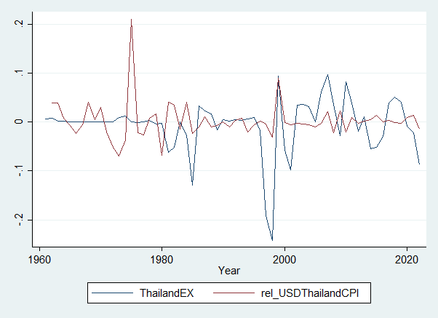

|  |  |  |  |
| --- | --- | --- | --- |
| ***ThailandEX*** |  | ***rel_USDThailandCPI*** |  |
|  |  |  |  |
| Mean | -0.006432007 | Mean | 0.00275132 |
| Standard Error | 0.007073986 | Standard Error | 0.004793954 |
| Median | 0 | Median | -0.002636519 |
| Standard Deviation | 0.055700623 | Standard Deviation | 0.037441979 |
| Sample Variance | 0.003102559 | Sample Variance | 0.001401902 |
| Kurtosis | 6.165732105 | Kurtosis | 15.69498273 |
| Skewness | -1.878803701 | Skewness | 2.905512012 |
| Range | 0.339113641 | Range | 0.280894175 |
| Minimum | -0.241663469 | Minimum | -0.070174173 |
| Maximum | 0.097450172 | Maximum | 0.210720003 |
| Sum | -0.398784405 | Sum | 0.167830509 |
| Count | 62 | Count | 61 |